**Bugs & Fixes of Note Taking App in Flask**

1. 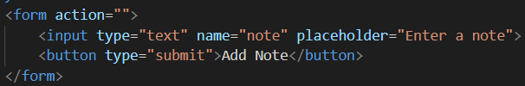Form action is not defined – The action that needs to be performed by the form submission is missing.

**Fix:**

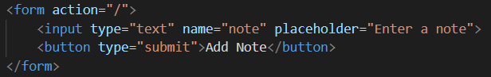This is a bad practice and can be fixed by adding ‘/’ in form action in html file as our desired code is in the ‘/’ route in app.py

1. 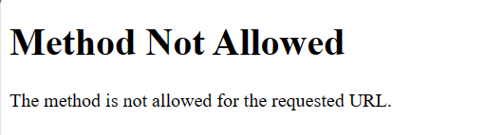Home route is using POST request – The route defined in app.py is only allowed for POST requests.

**Fix:**

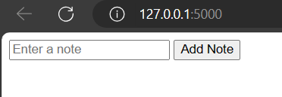Initially we are displaying the html to the user, so we need to read the server, this can be achieved through a GET request only, so I have updated the route with POST method as well.

1. 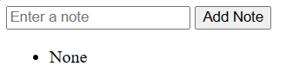In Index function, Not checking if note exists in note variable

**Fix:**

In the index function, it is not checking if there is a note existing, This is leading to show a None note. So it is vital to check if there is a note existing before displaying in webpage. I fixed it by adding an if condition in the index function in app.py

1. Missing button type in form – The button type is not mentioned for the add note button.



**Fix:**

In this case, it is the button for submitting the form, it is good practice to use a submit button for readability.